UV Index Chart Report

Southern Skin Cancer Treatment of America

Sabrina Kabir

November 2025

Table of Contents:
Company Introduction: 2

Analysis of the Problem: 2

Analysis of Current and Future States: 2, 3

Alternative Options: 3

Project Planning: 4

Design and Development of the Project: 5
IT Framework of the Project: 6

Coding Developments: 7

Ethics: 8

Support and Integration: 8

Conclusion: 9

References: 9

Introduction to Southern Skin Cancer Treatment:

The Southern Skin Cancer Treatment of America is a dermatology clinic that specializes in helping clients with their skin issues. They have 12 different locations across the country, but their main location is located in Dallas, Texas. To help their customers be more vigilant about UV exposure, the clinic wants to implement a UV Index Chart to curate predictions for UV index levels for a given city. No proposed budget was given to develop this project. In addition, the client did not request the project to be done through a specific integrated development environment (IDE).

The main purpose of this project is to build a chart that is accessible for all patients. Instead of having the company develop individual chart reports for all patients based on the places they currently reside in or might be travelling to. A deadline for the project was set to December 1st.

Analysis of the Problem:

Since customers of the company have different schedules on a daily basis, the company can’t customize individual reports for their customers. Therefore, to solve this issue at hand, the company wants to implement a UV index chart to their website on the 1st of January. This chart will help inform the customer of the current UV index ranges, which they can use to avoid certain ranges.

Analysis of the Current State:

The company does not have any current UV index chart among its website. Therefore, the company would like to implement a chart that their customers could have access to from the website.

Analysis of the Future State:

A request was made by the company to have the back end programming of the chart be built through HTML, CSS, and Javascript. The development of the chart will be implemented within a Github repository. The main source data will be drawn from the OpenMeteo website as requested by the company. The OpenMeteo website will provide the APIs for UV index levels according to the user’s request made through the Southern Skin Cancer Treatment website. The final interface will display dates of the user’s input, five days before the user’s input, as well as five days after the user’s input.

A process that might change during the development of this project is how the controls of the user interface will be handled and implemented. For example, the user might have the ability to only add in a zipcode to view the city’s index or they could have an option to type out the name of the city.

Regarding the choice of the technology, there might not be changes in terms of choosing the environment to add the code into. This is because the familiarity of the Github environment will allow me to develop and observe changes more consistently in terms of figuring out how the controls work.

Alternative Options for the Project:

An alternative option for the solution is to have the company list the website for the OpenMeteo website directly in their website. However, this option is not considered feasible since the customers would have to input extra controls to reach their desired outcome. For example, the name of the city or how they want their chart to be displayed. In addition, since the website contains numerous amounts of information, the customers of the company would have a harder time locating the chart.
Directly implementing a chart system for the customers to use in the company website is important because it provides a clear and concise result for the customers to view. In addition the following solution works better for the company because the company already has their main website set up, so they only need the coding aspect of the chart to implement into their website.

Project Planning Documentation:

Here is a Gantt chart of the plans for the project:

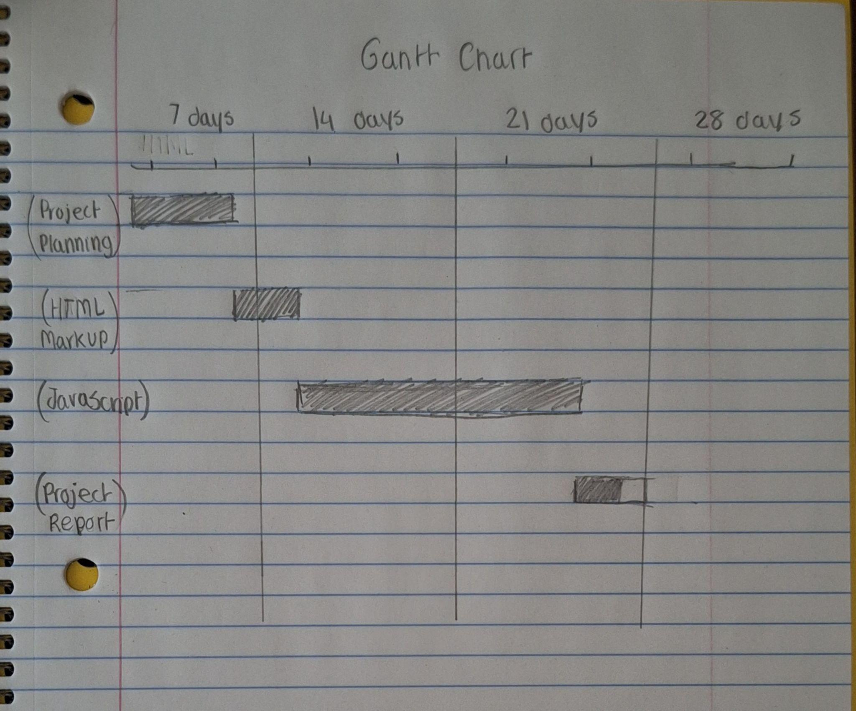

Design/Development and Interface of the Project:

The planning of the user interface included the following components:
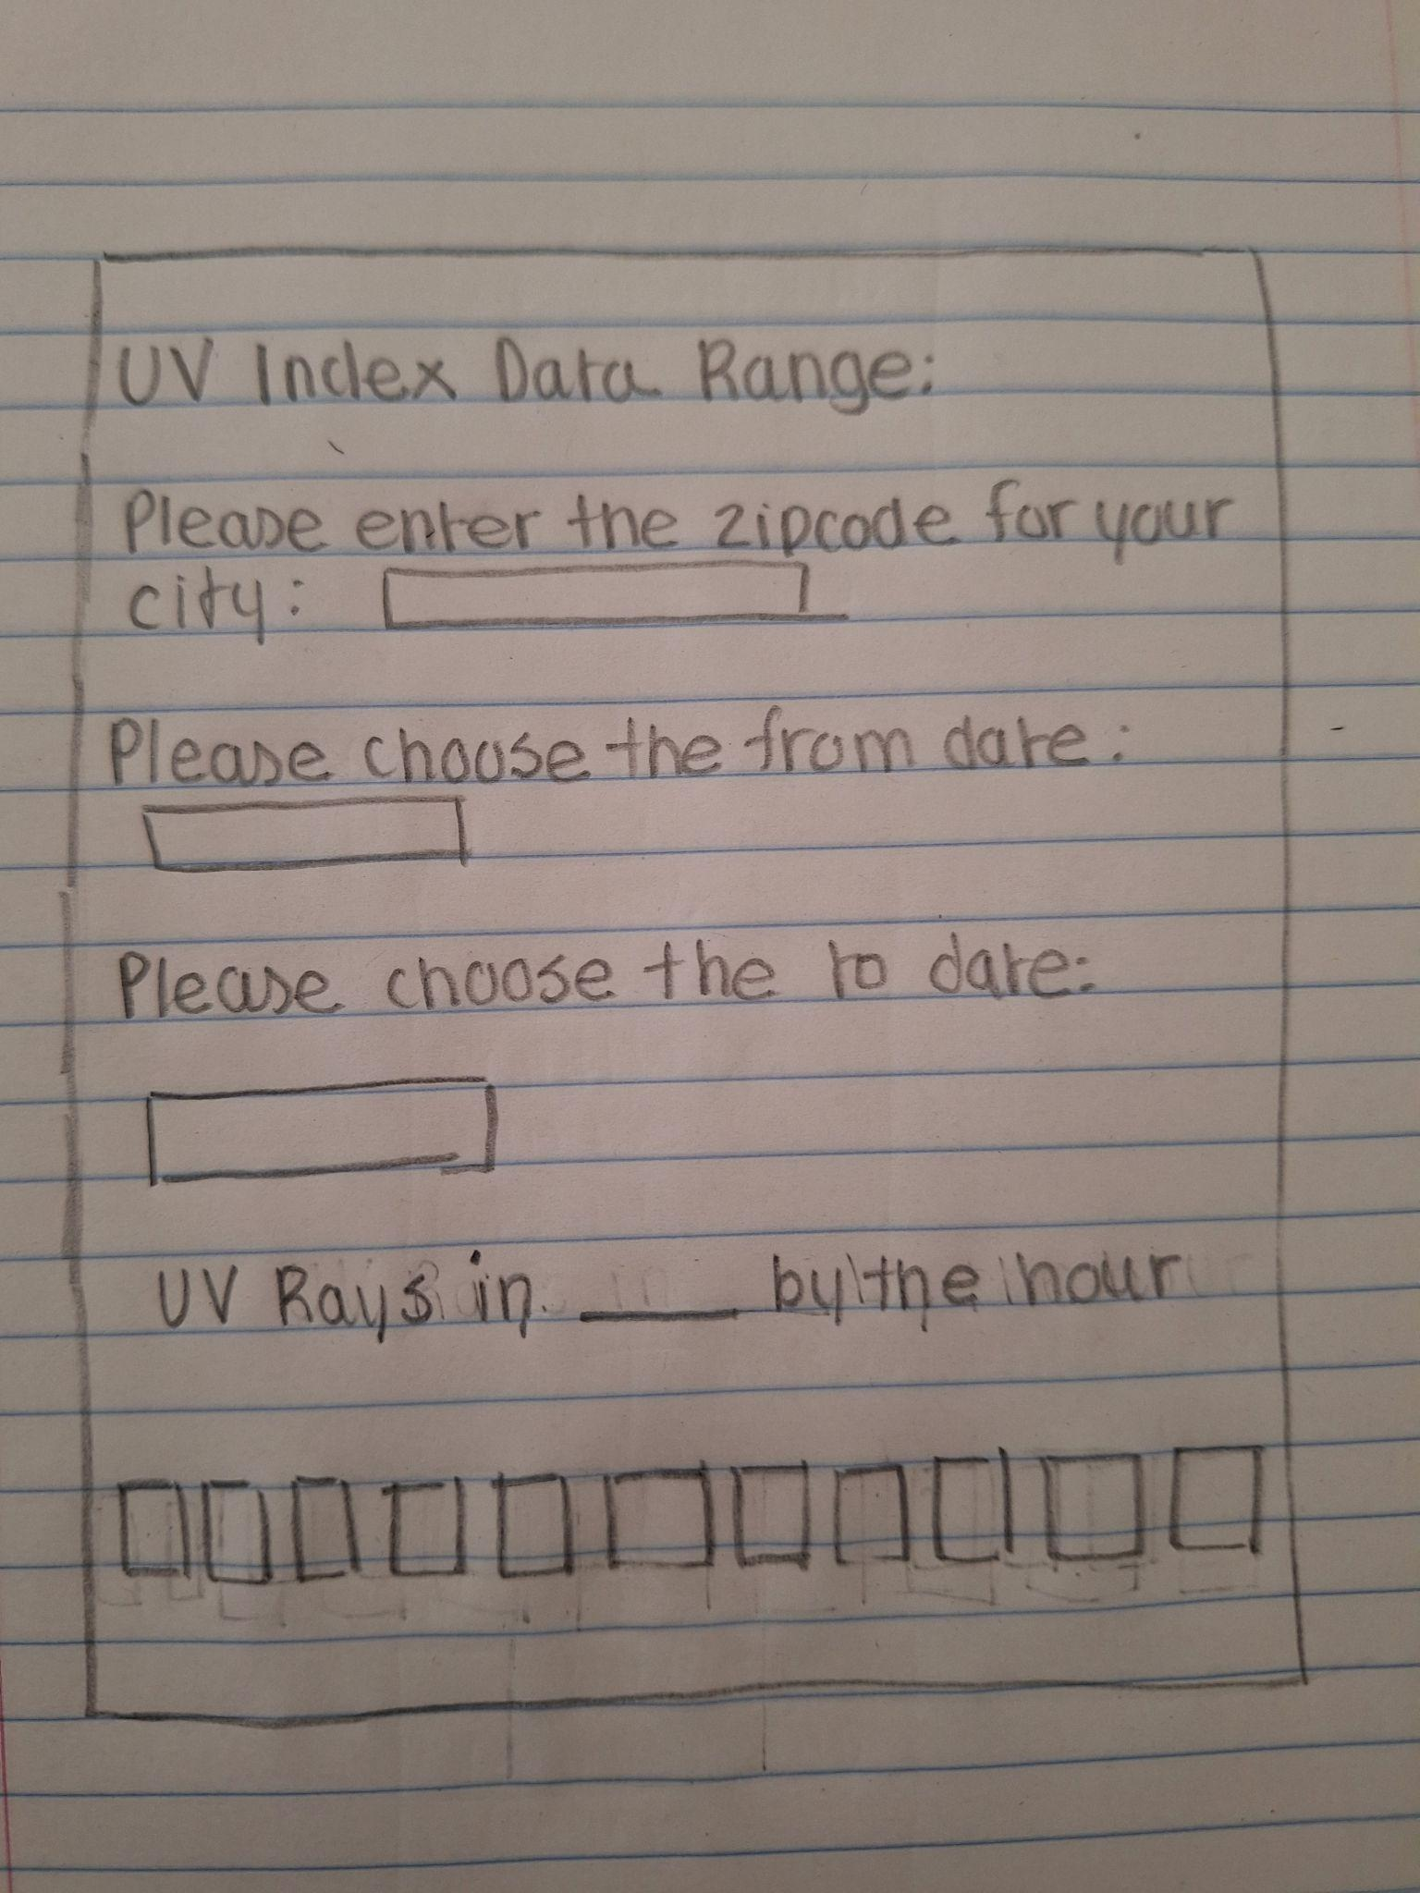

The final interface looked like the following:
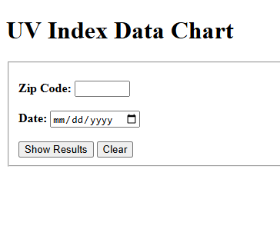

Only a few user-based inputs are placed to reduce time for the user to get their desired results. The date input will provide an automatically generated timeline of dates five days after the user’s choosing and five days before the user’s choosing within the constructed chart.

IT Infrastructure of the Project:
The Github repository system is a cloud-based environment, therefore stable internet connections were needed constantly to monitor and administer changes to the code. Since this project was implemented by a one-person team, version changes during the publishing process had notes along with them to serve as a reminder of what was changed.

Each component across the project had a connection with each other. The connection was further developed by an Entity-Relationship (ER) Diagram.

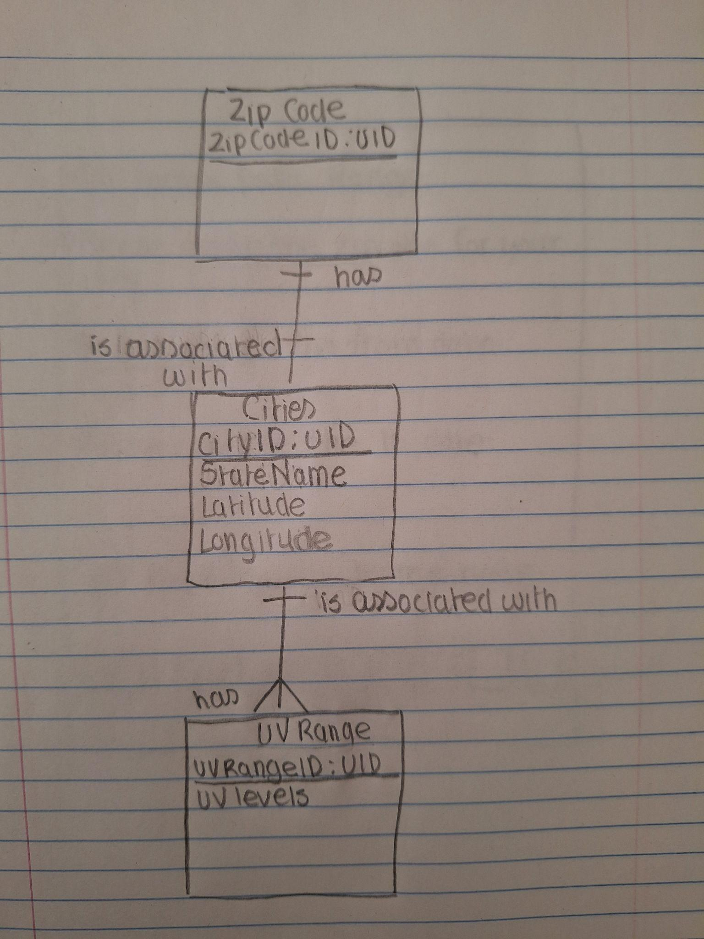

Since my project did not have a functionality to store individual data, there were no external privacy concerns that the project needed to store securely.

Code Development and its Results:

An example of a result from the code running had this type of output:

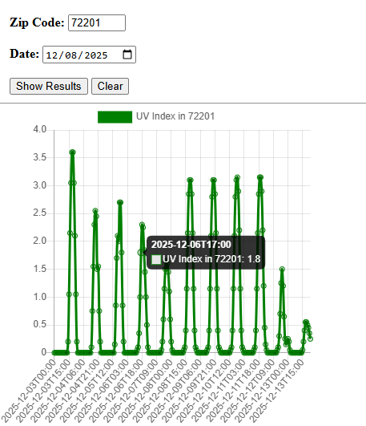

From this result, the user has the option to understand the different UV levels among a specific zip code. Data bars were provided among the chart to help the user find out the specific wavelength amount for a certain hour. Among the user interface, the user also has the option to clear the chart completely if they want to view the results for a different zip code.

Testing Methods Used:

A live server extension was added to the Github coding space to ensure that any changes being added were visible on the interface. It also allowed the ability to ensure that the functionalities being implemented were usable. As for the debugging methods, I utilized the developer tools extension on Chrome to find where errors typically occurred. By setting breakpoints across different sections, I was able to narrow down which parts work versus the parts that did not work.

Professional Responsibilities:

One of the code of ethics that have been used throughout the course of this project from the ACM code of ethics is the ability to maintain a professional status. By maintaining a professional status, I was able to communicate my plans by constructing a project analysis. In addition, this method had also allowed me to take responsibility in case my project deliverables had any missing criteria or requirements.

Ethical and legal issues:

As mentioned earlier, since my project did not have a separate functionality to store customer data, it didn’t have any specific legal requirements enacted to protect those inputted data. This project also did not include the work of any external source (other than OpenMeteo) which had copyright claims.

Support and Integration:

The client mainly requested the coding aspect of the project. They can implement this coding into their website by having a copy of the Javascript, HTML, and CSS files. If one of the company’s goals is to store customer data of zip codes, then they should have a form of encryption among their website to hide the information that their customers input.

Conclusion:

I am very grateful that I had the opportunity to have a chance to complete this project. This project allowed me to understand how API calls work in real-time. It also allowed me to develop my planning skills throughout the course of the project. I would also like to thank my professor, Mr. Bruce Bauer, for his advice and guidance throughout the course of this project. Thanks to him, I was able to understand how to sort the date and time variables in my Javascript section.

References:

OpenMeteo: https://open-meteo.com/en/docs

ACM (Code of Ethics): https://www.acm.org/code-of-ethics

